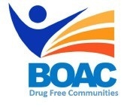

MBroeomet OipioidgAwareness Council

November 1, 2019 | 10am-12pm

Conference Rooms B&C • Broome County Health Department

**Agenda**

**Call to Order:** Marissa Lamphere- Opioid Overdose Prevention Coordinator

**Welcome and Introductions**

1. **Presentation-** William Eggelston**,** PharmD, DABAT

Assistant Professor, Binghamton University School of Pharmacy

Clinical Toxicologist, SUNY Upstate Medical University

Director, Opioid Research Center for Central New York (ORCC-NY)

1. **Sub Committee Updates**

* Broome County Prevention Coalition
* Media and Advocacy Committee
* Data & Statistics Committee
* Peer Response Committee
* Treatment and Prevention Committee
* Rural Committee

1. **Other Announcements/Business**

**\*\*Next meeting will be held Friday 12/6 at 10am at the Broome County Health Department**

**Next Meeting:** Friday November 1st 10am- Broome County Health Department