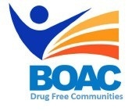

MBroeomet OipioidgAwareness Council

April 5th, 2019 | 10 a.m- 11 am

Conference Rooms B&C • Broome County Health Department

**Agenda**

**Call to Order:** Marissa Lamphere- Opioid Overdose Prevention Coordinator

**Welcome and Introductions**

1. **Approval of March Meeting Minutes**
2. **State of Emergency updates-** Rebecca Kaufman**-** Public Health Director
3. **Committee Updates:**

* Broome County Prevention Coalition (Formerly Community Education)
* Media and Advocacy Committee
* Peer Response & Law Enforcement Committee
* Treatment and Prevention Committee
* Data and Statistics Committee
* Rural Committee

1. **Other Announcements/Business**

**Next Meeting:** May 3, 2019 10am-12pm BCHD