BROOME COUNTY
DEPARTMENT OF AUDIT AND CONTROL

ACCOUNTS PAYABLE DOCUMENTATION AUDIT

THIRD QUARTER 2016

Alex J. McLaughlin, Comptroller
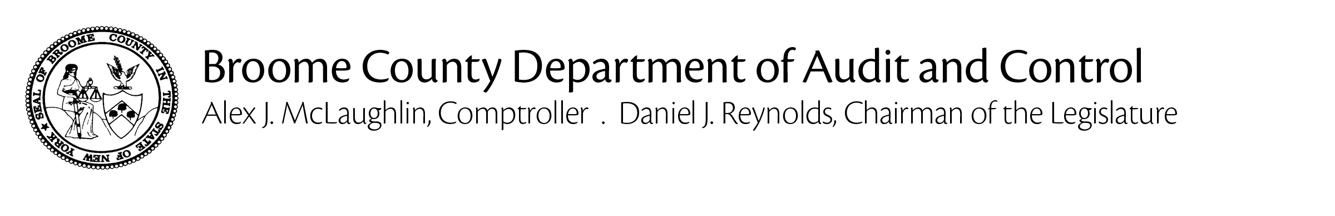
January 18, 2017

Jason T. Garnar, County Executive

The Department of Audit and Control has performed an audit of Accounts Payable documentation for the third quarter of 2016. The principal objective was to verify that amounts disbursed through the accounts payable process were proper in accordance with all applicable laws, regulations and policies and that they are supported by adequate, competent documentation.

The audit was conducted in accordance with generally accepted auditing standards. Such standards require that the Department of Audit and Control plan and perform the audit to adequately assess the accuracy of the financial records and adequacy of the internal controls and that we examine, on a test basis, sufficient, competent and relevant evidence to afford a reasonable basis for our conclusions.

Based on the results of our examination, it is our opinion that, except for the instances described herein, amounts disbursed through the accounts payable process were proper in accordance with all applicable laws, regulations and policies and that they are supported by adequate, competent documentation.

Sincerely,

Alex J. McLaughlin
Comptroller

Cc: Daniel J. Reynolds, Chairman of the Legislature
Members of the Legislature
Aaron M. Martin, Clerk of the Legislature
Kevin M. McManus, Deputy County Executive
Department Heads, Fiscal Contacts
BACKGROUND

Weekly, Broome County processes more than 1,000 vouchers, cuts nearly 500 checks and disburses nearly $7 million through its accounts payable system.

The Department of Audit and Control is responsible for auditing all of these disbursements to ensure that they are an appropriate use of County funds, that they are proper in accordance with all applicable laws, regulations and policies and that they are supported by adequate, competent documentation.

We use a two-step process to fulfill our auditing obligations with regard to accounts payable. First, we examine an electronic version of every payment request to ensure that it is appropriate, properly classified and made in accordance with applicable laws, regulations and policies. If these criteria are satisfied, the disbursement is approved. Then, we select a sample from these disbursements for detail testing. We visit each department and verify that the backup maintained to support the selected disbursements is adequate, correct and complete.

Any instances of non-compliance that we identified are included in this report.

REPORTABLE CONDITIONS

- CENTRAL FOOD

Central Food paid bills for contracted food services that included charges for items not specified in the applicable contract. Specifically, $2,188.16, for items such as guest trays, comfort trays, side items and pantry supplies.

The Department explained that such charges are common and should have been included
in the contract. We advised that the charges would have to be credited back to the County and that only items specified in the contract could be paid for.

The Department will process an amendment to the contract.

- PUBLIC WORKS

Public Works paid an electrical contractor’s bill that did not include required supporting documentation for labor and materials.

- PARKS

The Parks Department paid a contractor’s bill that did not include required supporting documentation for materials.

