BROOME COUNTY
DEPARTMENT OF AUDIT AND CONTROL

ACCOUNTS PAYABLE DOCUMENTATION AUDIT

SECOND QUARTER 2018

Alex J. McLaughlin, Comptroller
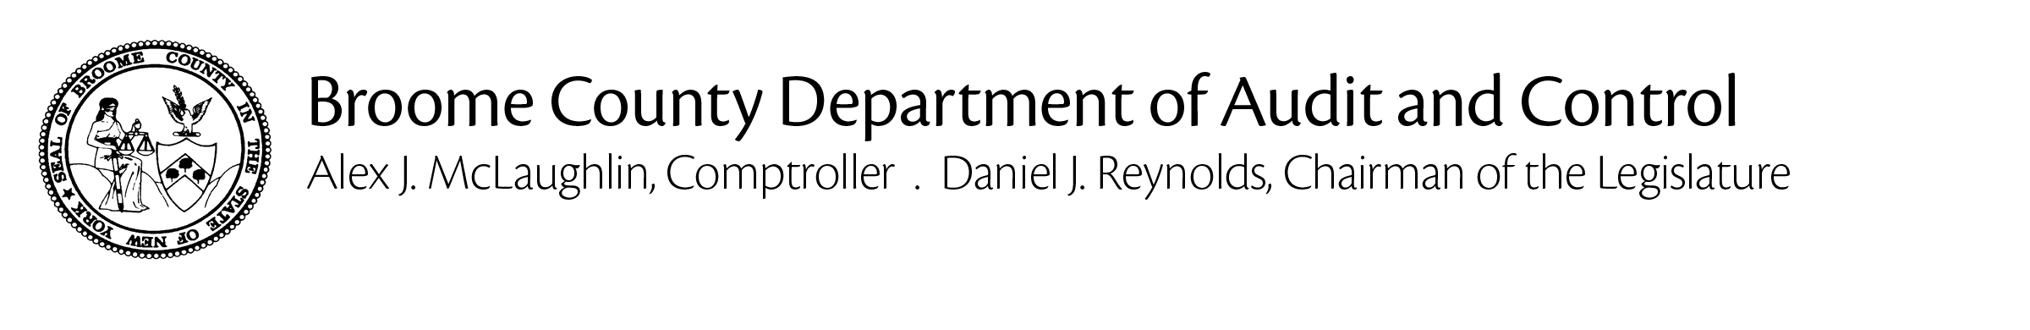
December 19, 2018

Jason T. Garnar, County Executive:

The Department of Audit and Control has performed an audit of Accounts Payable documentation for the second quarter of 2018. The principal objective was to verify that amounts disbursed through the accounts payable process were proper in accordance with all applicable laws, regulations and policies and that they are supported by adequate, competent documentation.

The audit was conducted in accordance with generally accepted auditing standards. Such standards require that the Department of Audit and Control plan and perform the audit to adequately assess the accuracy of the financial records and adequacy of the internal controls and that we examine, on a test basis, sufficient, competent and relevant evidence to afford a reasonable basis for our conclusions.

Based on the results of our examination, it is our opinion that, except for the instance described herein, amounts disbursed through the accounts payable process were proper in accordance with all applicable laws, regulations and policies and that they are supported by adequate, competent documentation.

Sincerely,

Alex J. McLaughlin
Comptroller

Cc: Daniel J. Reynolds, Chairman of the Legislature
Members of the Legislature
Aaron M. Martin, Clerk of the Legislature
Kevin M. McManus, Deputy County Executive
Department Heads, Fiscal Contacts
BACKGROUND

Weekly, Broome County processes more than 1,000 vouchers, cuts nearly 500 checks and disburses nearly $7 million through its accounts payable system.

The Department of Audit and Control is responsible for auditing all of these disbursements to ensure that they are an appropriate use of County funds, that they are proper in accordance with all applicable laws, regulations and policies and that they are supported by adequate, competent documentation.

We use a two-step process to fulfill our auditing obligations with regard to accounts payable. First, we examine an electronic version of every payment request to ensure that it is appropriate, properly classified and made in accordance with applicable laws, regulations and policies. If these criteria are satisfied, the disbursement is approved. Then, we select a sample from these disbursements for detail testing. We visit each department and verify that the backup maintained to support the selected disbursements is adequate, correct and complete.

Any instances of non-compliance that we identified are included in this report.

REPORTABLE CONDITIONS

- PUBLIC WORKS

The Department of Public Works overpaid consulting engineers by $3,417.75 as a result of paying rates stipulated in an expired contract rather than those stipulated in a new contract. The overpayment was refunded to the County by the engineering firm.

